MEETING TEMPLATES - SimPEG

Subject/Purpose | - SimPEG Organizational meeting

Organizer’s Name | Eldad Haber, Rowan Cokett |  |  | Date | 2013-06-04
Organizer’s Location | ESB 4013
Meeting date/ location | GIF room | from: | 13:00 | to: | 14:00

ATTENDANTS
No | Name | Initials | Rol
1 | Eldad Haber | EH | Moderator
2 | Rowan Cokett | RC | Moderator
3 | Dave Marchant | DM | Moderator
4 | Lars Ruthotto | LR | Participant
5 | Roman Shetkman | RS | Participant
6 | Luz Angelica Caudillo Mata | LACM | Participant
7 | Kristofer Davis | KD | Participant
8 | Seogi Kang | SK | Participant
9 | Jenn Fohring | JF | Participant
10 | Wing Wa Yu | WY | Participant

PRE-REQUISITES
Description | Who
Python code for Quasi-static Maxwell's Equations in Freq domain | EH
Git-Bitbucket repository set up for the group | RC,DM

AGENDA
Hours of |  | Time (min) |  | No | Topics | Discussion  Leader
Start | End | Plan | Real | No | Topics | Discussion  Leader
13:00 |  |  |  | 1 | Meeting purpose, Introduction | EH
 |  |  |  | 2 | Advantages and disadvantages of Python | DM
 |  |  |  | 3 | Code overview | EH
 |  |  |  | 4 | Next steps | EH,RC,DM

Totals | 60 | 60

ACTIVITIES, ACTIONS AND IMPORTANT INFORMATION
No | What | Who | When
1 | Object Oriented Programming Tutorial | DM | 2013-06-11
2 | Open bitbucket account and install SourceTree and Git | All | 2013-06-11
3 | Send email to be included in Bitbucket repository | All | 2013-06-11
4 | Install Python (go to https://www.enthought.com/) | All | 2013-06-11
5 | Visualization of scalar and vector fields with python | JF | 2013-06-11
6 | Interpolation with python | SK | 2013-06-11
7 | Clean up Python MEF code | RC | 2013-06-11
8 | Put code in bitbucket repository and send theory notes | EH | 2013-06-06

Notes

MEETING SUMARY

- Meeting's purpose and introduction.
EH said that it is time to make a group effort to create software that can be distributed. We will experiment with Python, which is a programming language that allow us to do similar things to MATLAB without the restriction of being a proprietary system.

- Advantages and disadvantages of Python.
Advantages: Open source, Offer similar characteristics to MATLAB, without the restrictive part, Balance of low level and high level programming, Language interoperability, Documentation System, Available libraries
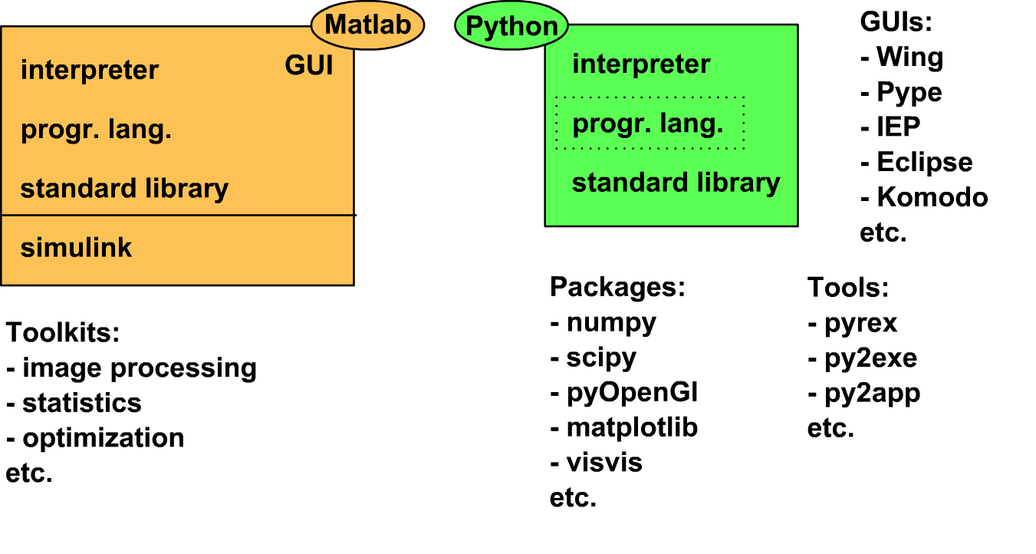
Figure 1. Phyton vs Matlab

Disadvantages: Learning curve (this really depend on the programmer), current landscape of conventions and available resources.

More sites to read:
http://www.stat.washington.edu/~hoytak/blog/whypython.html
https://sites.google.com/site/pythonforscientists/python-vs-matlab

- Code Overview.
The current code developed by EH considers the Finite Volume discretization of the weak formulation of the Quasi-Static Maxwell's equations in Frequency Domain. Where the magnetic permeability and the conductivity are scalar functions. The discretization is done using Logical Orthogonal Meshes.
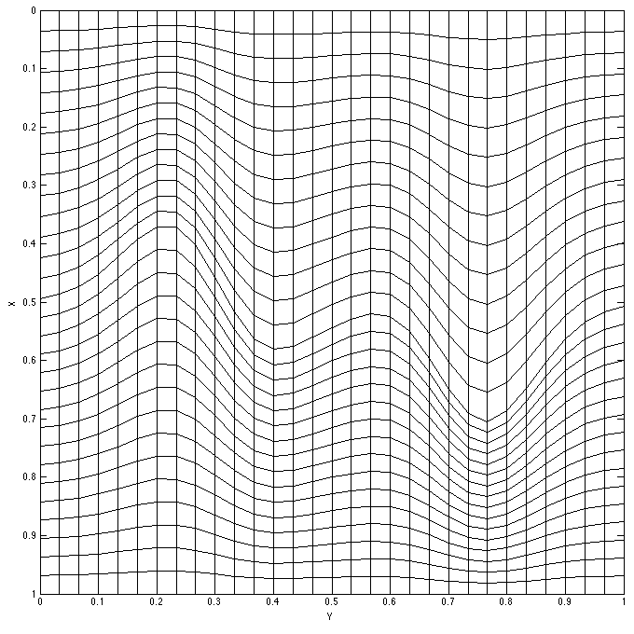
Figure 2. Logical Orthogonal Meshes

- List of sub projects
  - Sources programing
  - Solvers (iterative and direct)
  - Fields visualization
  - Pre conditioners
  - Derivatives and sensitivities
  - Input/Output
  - Regularization
  - Interpolation

AGREEMENTS
- Code will be developed using Object Oriented Programming paradigm with Python.
- Start with Quasi-Static Maxwell's Equations in Frequency Domain where the parameters are scalar functions. Mesh used: Logical orthogonal.
- We will base the code on the one developed by EH.
- RW will be the “goal keeper”
- Meetings will be held in the GIF room every one or two weeks depending on work done.
- This is a group effort, we are all responsible to make this work.
- Project's title is SimPEG.

COMMENTS AND OTHER TOPICS TO BE DISCUSSED IN FURTHER MEETINGS
- Our code standards
- General organization (Logo of the project?)

